Surin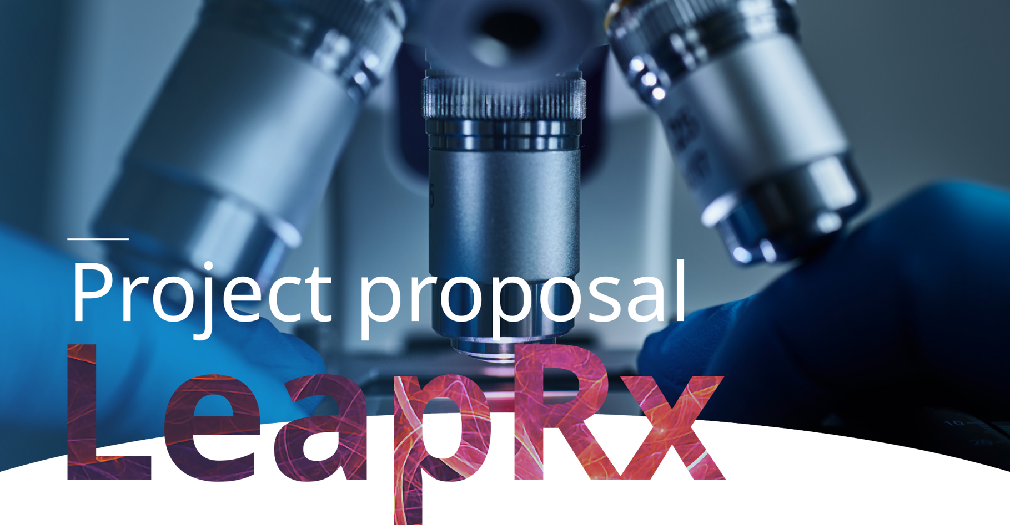
  Title
  Type your project title here
  Institution
  Type the institution name here
  Phone
  Type your phone number here
  Name
  Type your name here
  E-Mail
  Type your e-mail here
  Therapeutic Area & Indication
  Type your therapeutic area & indication here

Technology Scope - Please select your choices or elaborate further in the text field.

  ☐ | Small Molecule
  ☐ | Biologic
  ☐ | Gene Therapy/Gene Editing

  ☐ | Oligonucleotide/mRNA therapies
  ☐ | Cell-Based Therapies

- Write more regarding the technology scope here if relevant

 | 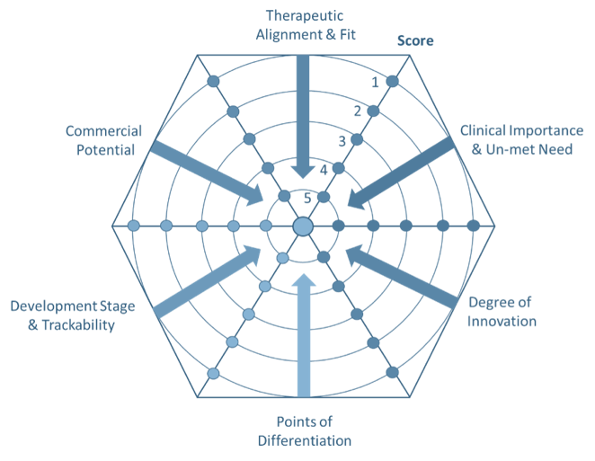
  Evaluation Criteria
  LeapRx considers a number of factors when evaluating your application to ensure the program is therapeutically aligned with the mission of the accelerator and that the information provided in the application addresses a number of key areas that will be considered during the review process. The key areas on which an application will be evaluated and scored are depicted in the figure below.

Project Description - (1-2 sentences)

- Summarize your project concept in 1-2 phrases – this sets the stage for the following topics.

Therapeutic alignment - (1-2 sentences)

- How is your project aligned with the therapeutic focus areas of LeapRx?

Clinical importance and unmet need

- What is the intended therapeutic use(s)?
- What is the unmet need in the US and worldwide (patient population(s))?
- What is the likely clinical impact of this technology?

Degree of Innovation - Please summarize the scientific innovation and novelty of mechanism of action here.

- What is the scientific and biological rationale and the mechanism of action (if known) linking target/pathway to the disease/clinical indication?
- What is the innovation maturity? robust and compelling proof-of-concept data will help build the case that your idea can be matured

Points of Differentiation

- How does this project differentiate from existing therapies or approaches? What makes this program unique - new target? New compound/biologic? Unexpected findings?
- Could the project bear platform technology potentials? Could other targets be addressed with similar approach?

Stage & Ease of Development - Please indicate stage of development.

  ☐ | - Discovery
  ☐ | - Hit to Lead
  ☐ | - IND enabling stage

  ☐ | - IND enabling stage
  ☐ | - Lead Optimization
  ☐ | - Clinical Stage

- Summarize key results obtained to date including in-vitro, in-vivo, genetic data, (e.g. knock-in, knock-out, or genetic basis for the disease if appropriate) on which the scientific & biological rational is based.
- If applicable, include data supporting human translation, e.g. relevancy of animal model used, human data, genome-wide association study (GWAS), target expression across species, sequences homology.

What is the ease of development?

- How readily can the program be further developed?
- How challenging is e.g. the medicinal chemistry? Does the molecule have good pharmaceutical properties (soluble, permeable, drug like properties, stable – will this be a challenge to improve?)
- Are good animal or diseases models available?
- Are patients readily available for trials?
- Are clinical endpoints in place?
- Are there any predictive/prognostic biomarkers?
- Is a clear regulatory path?
- How successful have other programs been in this space?
- What is the scalability potential? (demonstrating that your idea can feasibly be taken beyond the bench and implemented at scale or higher throughput is a key component of a successful partnership)
- How does the future plan outline look like in your opinion

What is the commercial potential?

- Market size/likely commercial potential of the target product.
- IP status & scope
- Known competitors / similar programs

Submission Details

Please return your application to Molly Mesko: meskom@discoveredi.org

